ASSIGNMENT 3 REPORT

Name: Artur Jaxyagaliy

Group: SE-2429

**Part 1: Flexbox**

Task 0 - Navigation Bar

Description:

Created an adaptive header with a logo on the left and navigation links on the right. I used Flexbox to align the logo and links horizontally and vertically in the center. Added spacing between links for clarity.

Task 1 - A row with cards

Description:

I created a series of three project cards, each of which contains an image, a title, a description and a button. Inside each card, I used a Flexbox to vertically distribute the contents. Provided the same height for all cards and added a hover effect for visual interactivity.

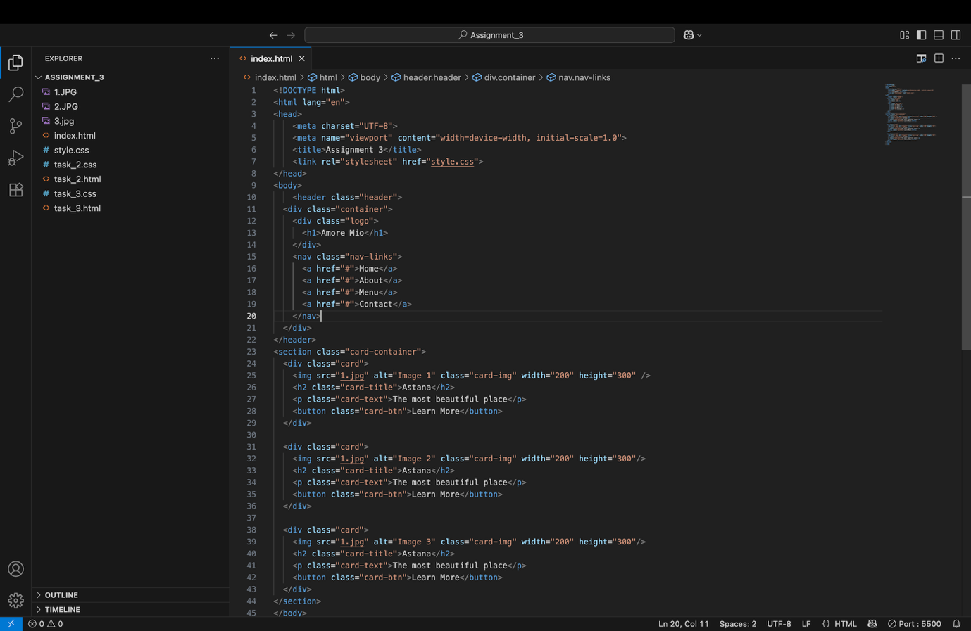

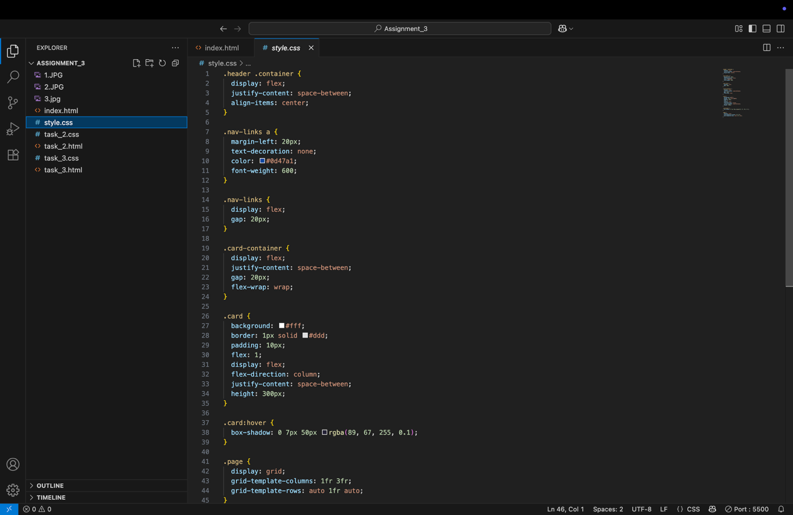

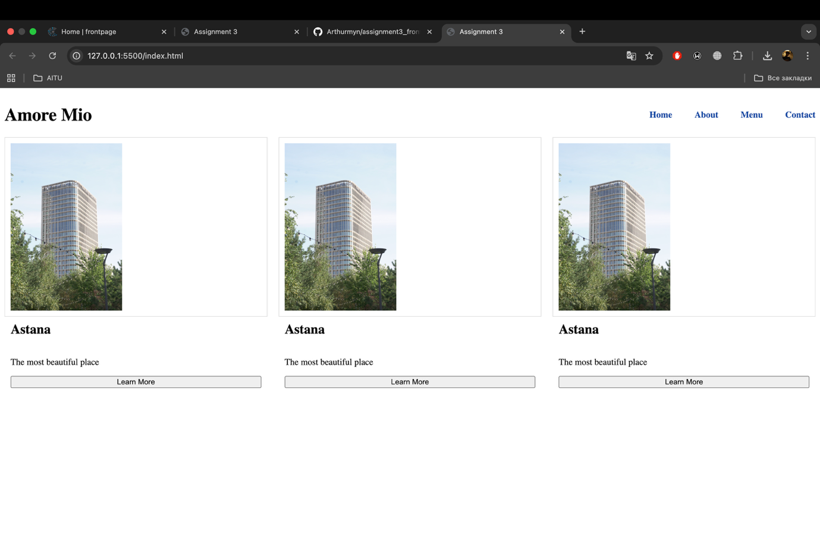

**Part 2: Grid System**

Task 2 - Page Layout with Grid Areas

Description:

Designed the main page layout with header, sidebar, main content, and footer using CSS Grid. Assigned grid areas to ensure the header spans the top, sidebar is on the left, main content on the right, and footer spans the bottom.

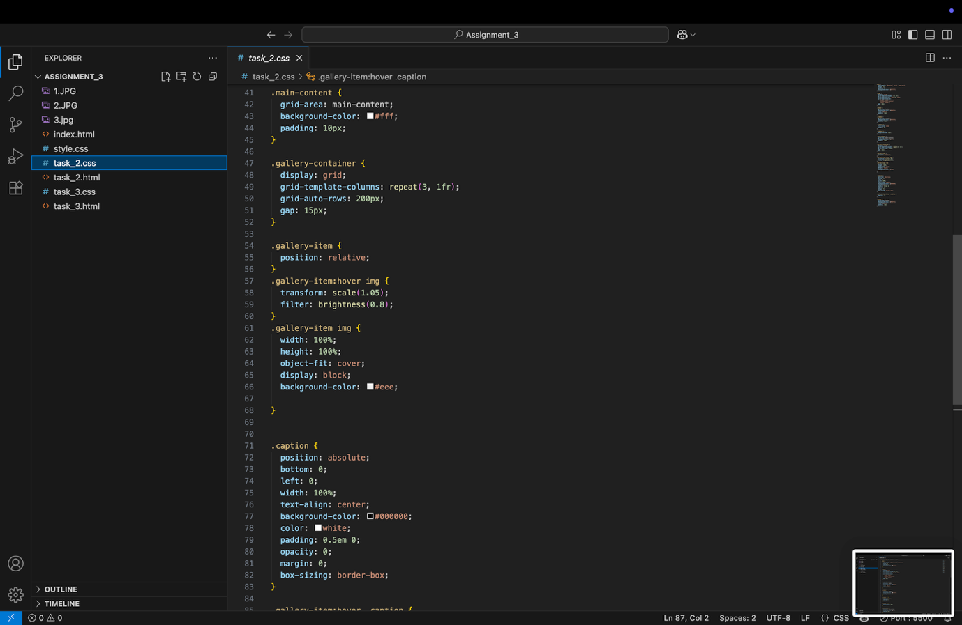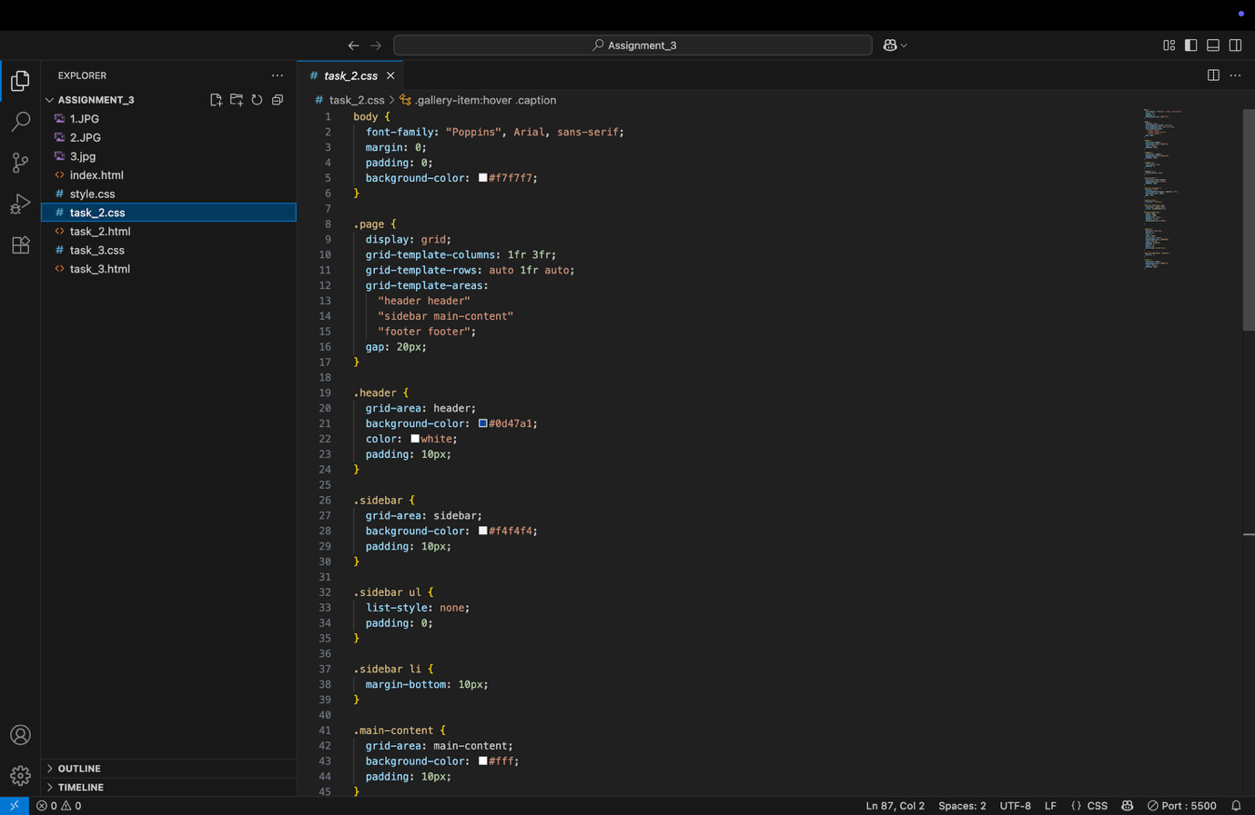

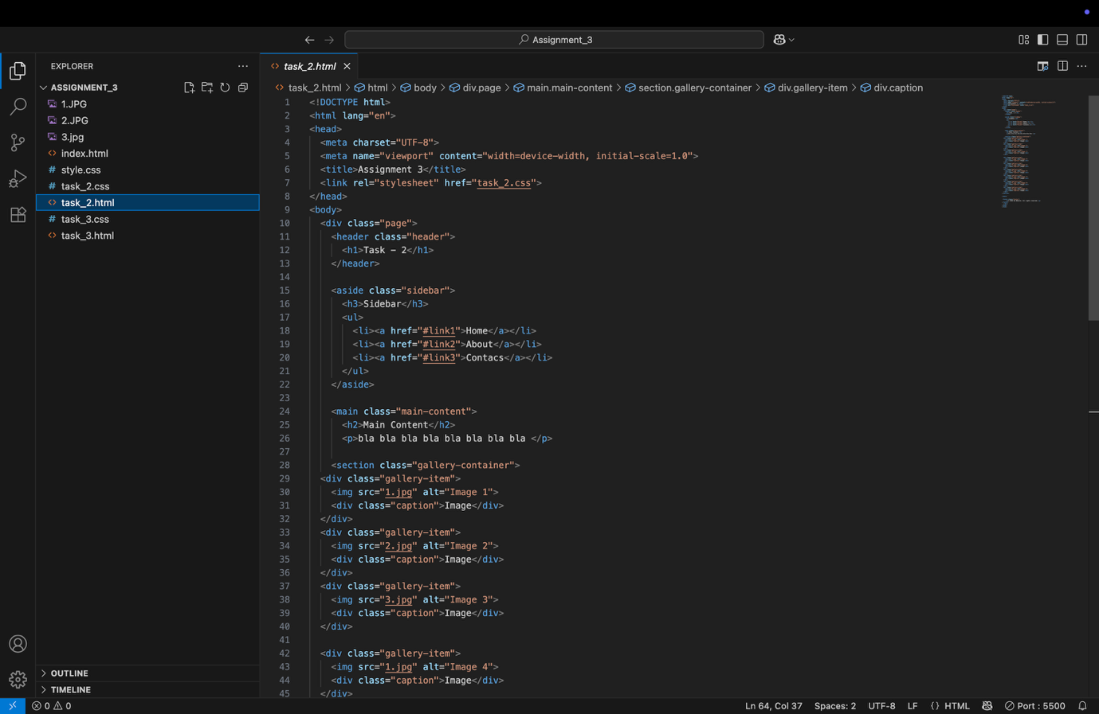

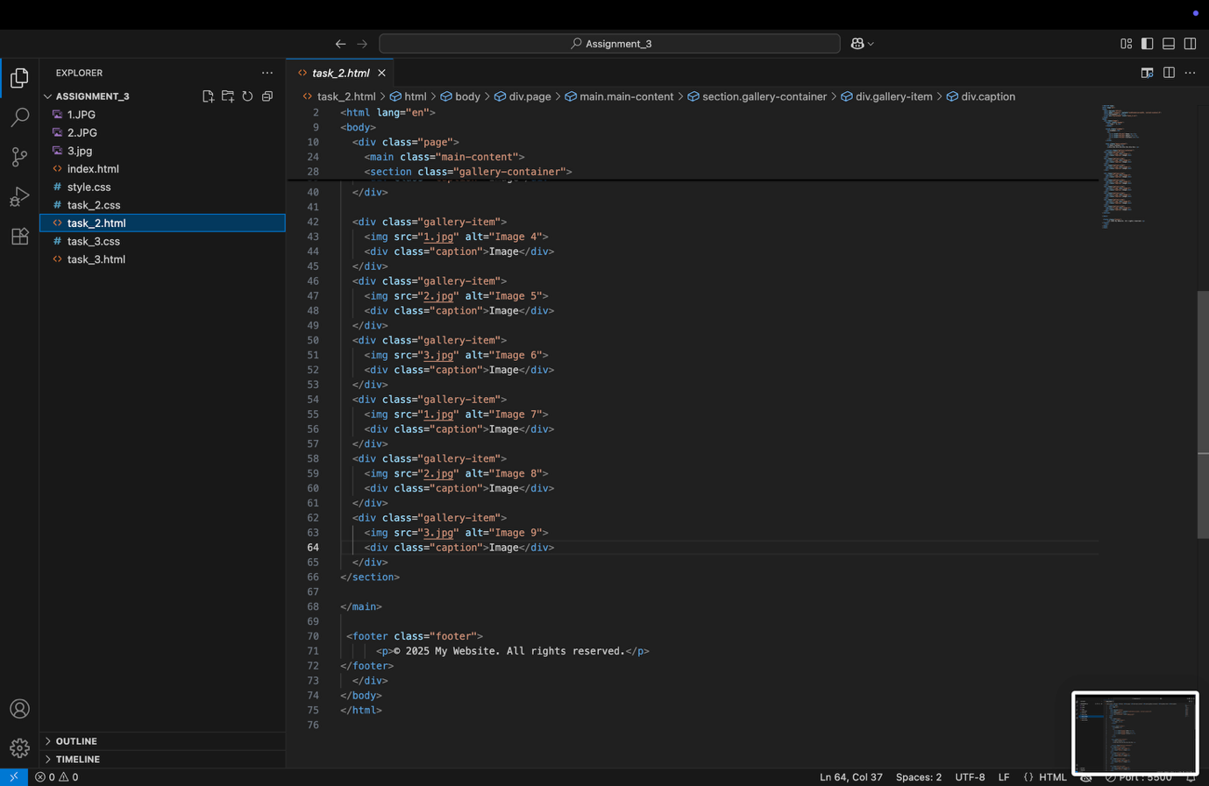

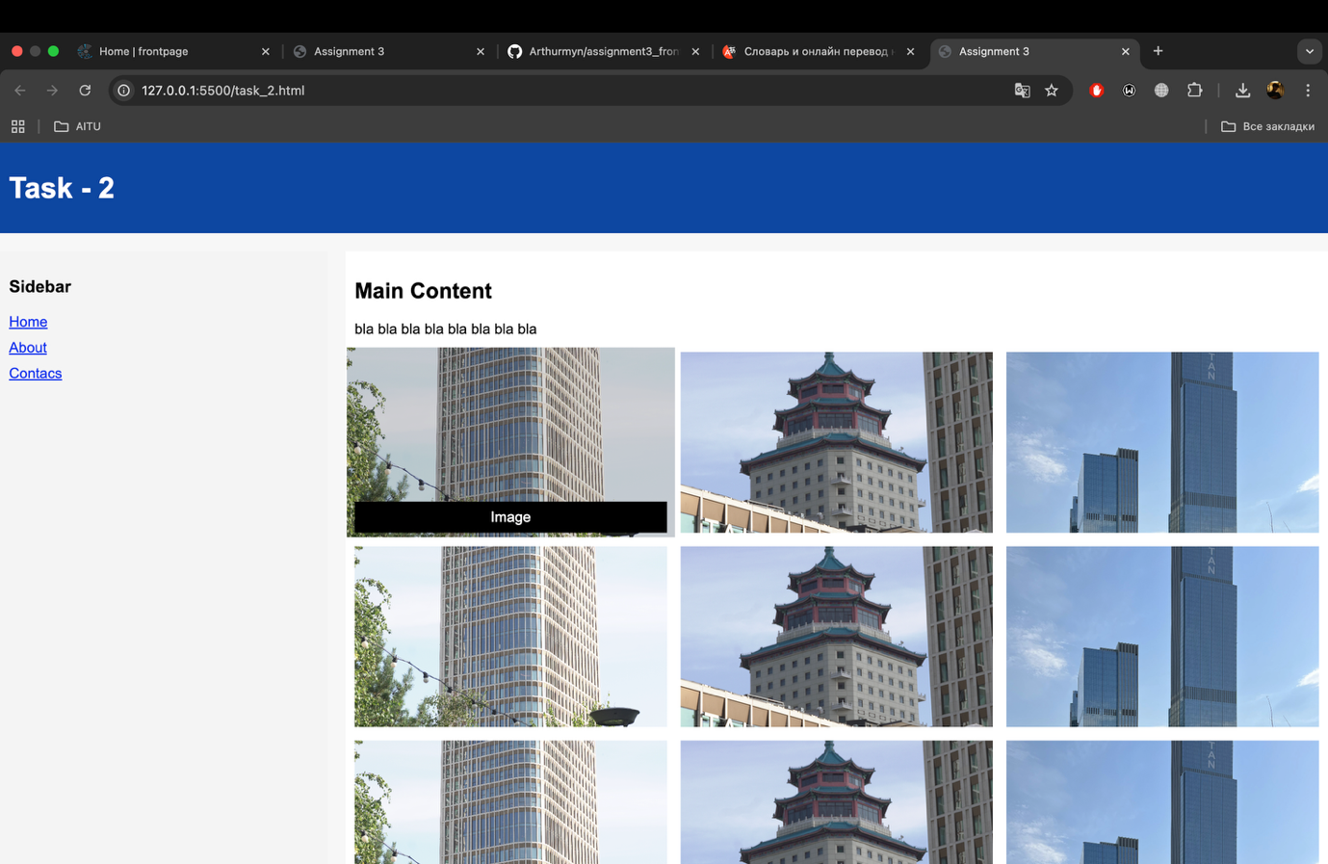

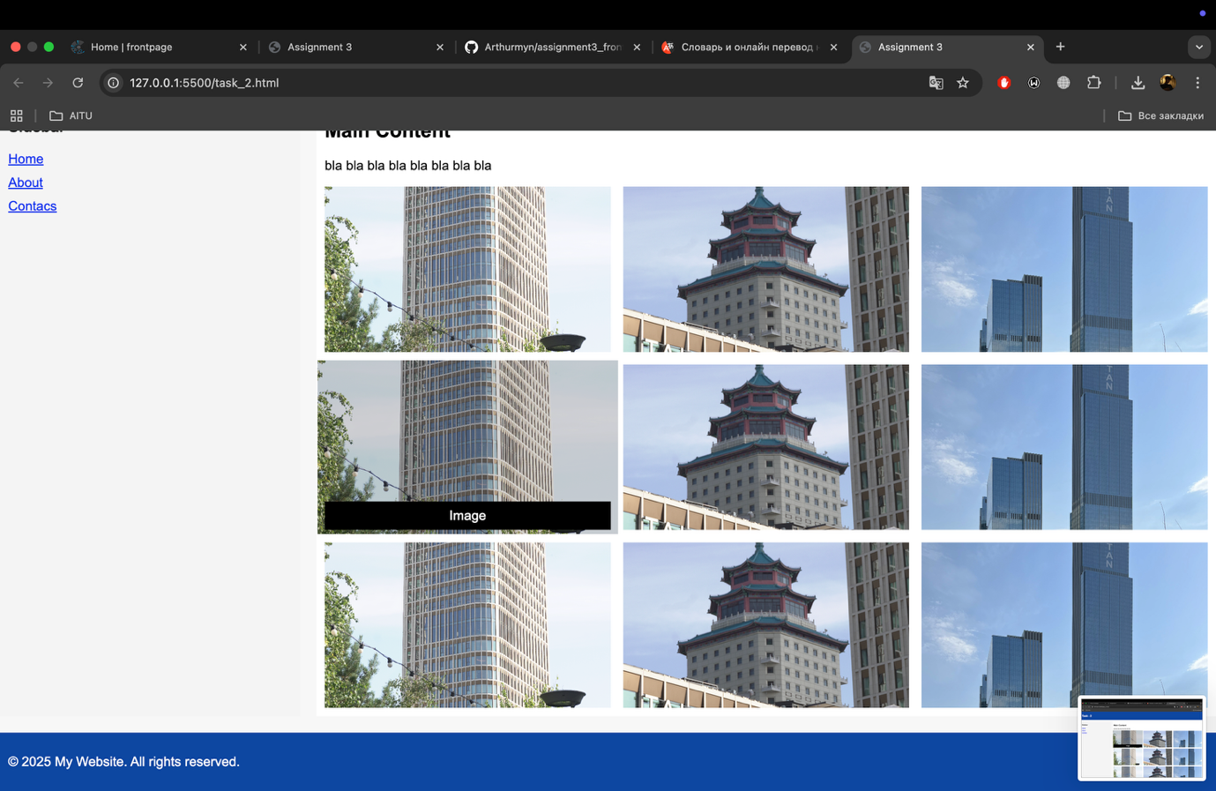

**Task 3 - Image Gallery**

Description:

Created a gallery with at least nine images arranged in a CSS Grid. Defined equal-width columns and rows, added consistent gaps between images, and implemented a hover effect to display a caption overlay. Ensured images maintain their aspect ratio.